**Bank Loan Performance Analysis**

INTRODUCTION

This project shown to customers lending loan dataset to uncover the relationship between borrower behaviour (such as employment length, income, and debt-to-income ratio) and loan characteristics (including amount, term, and interest rate) to unearth critical insights into loan performance metrics. By examining patterns in loan statuses such as fully paid, charged off, or late payments, this analysis aims to empower banking institutions with actionable insights to optimize loan lending strategies, I have attached the workfile below for your reference.

Steps

Data cleaning and data transformation

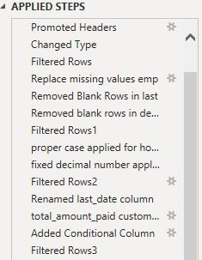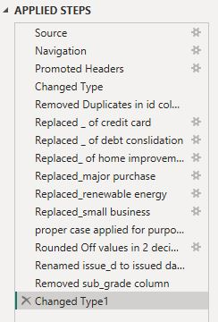

Ref : these are the steps have done for the data transformation and data cleaning to given data file.

Data modeling:

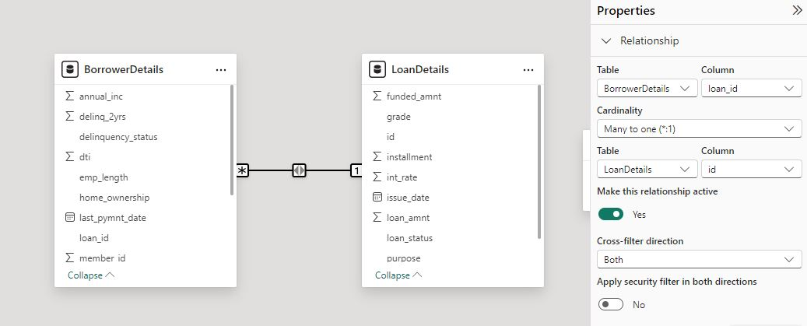

Creating Measures and Calculated Columns using DAX

**Remaining_installments** = CEILING(BorrowerDetails[out_prncp]/RELATED(LoanDetails[installment]),2)

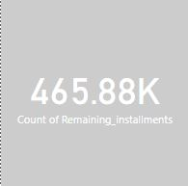

**Non_verfied borrowers count** = CALCULATE(COUNT(BorrowerDetails[verification_status]),FILTER(BorrowerDetails,BorrowerDetails[verification_status]="Not verified"))

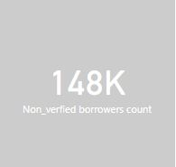

**Fully paid loan percentage** = ROUND( DIVIDE( CALCULATE( COUNT(LoanDetails[loan_status]), FILTER(LoanDetails, LoanDetails[loan_status] = "Fully Paid") ), COUNT(LoanDetails[id]) )*100,0 )

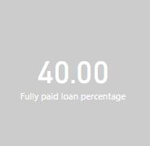

Creating Comprehensive Reports

Report 1: Loan Performance Analysis

➢ **Total Funded Amount**: Create a card visual to display the total funded amount.

➢ **Fully Paid Loan Percentage**: Create a gauge chart to display the 'Fully Paid Loan Percentage' measure.

➢ **Average Interest Rate by Term**: Create a multi-row card to show the average interest rate for each term.

➢ **Loan Status Distribution**: Create a pie chart to visualize the sum of total payments by loan status. ➢ Loan Amount by Purpose: Create a treemap to show the average loan amount by purpose.

➢ **Installment Over Time**: Create a line chart to visualize the sum of installments by Year and Quarter of the issue date.

➢ **Maximum Total Amount Paid by Loan Status**: Create a column chart to display the maximum total amount paid by loan status.

➢ **Minimum Annual Income by Grade**: Create a funnel chart to show the minimum annual income by grade.

➢ **Issue Date Slicer**: Add a slicer for the Month of the issue date to enable dynamic data exploration

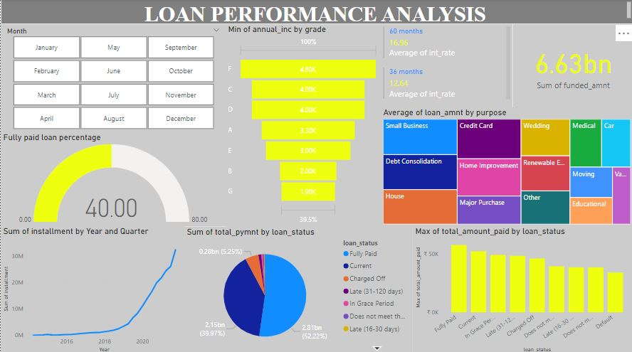

here I gave a proper insights for given loan performance analysis data file.

Report 2: Borrower Profile Analysis

➢ **KPI Visual**: Create a KPI visual with the sum of total payment as the value, the year of last payment date as the trend axis, and the sum of loan amount as the target. Round off to 2 decimal points and format as $ currency

. ➢ **Average of Annual Income**: Display the average of annual income using a card visual.

➢ **Non-Verified Borrowers Count**: Display the count of non-verified borrowers using a card visual.

➢ Average Debt-to-Income by Delinquency Status: Create a multi-row card to show the average debt-to-income ratio by delinquency status.

➢ **Sum of Loan Amount by Home Ownership**: Create a table to show the total loan amount by home ownership.

➢ **Average Remaining Principal by Verification Status**: Create a donut chart to display the average remaining outstanding principal by verification status.

➢ **Sum of Delinquencies by Home Ownership**: Create a bar chart to show the total number of delinquencies in the past 2 years by home ownership and filter the visual to display only Mortgage, Rent, and Own.

➢ **Max Remaining Installments by Employment Length**: Create a treemap to show the maximum remaining installments by employment length.

➢ **Total Amount Paid and Funded Amount Over Time**: Create a line chart to display the sum of total amount paid and the sum of funded amount by the year of last payment date.

➢ **Purpose Slicer**: Add a slicer for loan purpose to enable dynamic data exploration

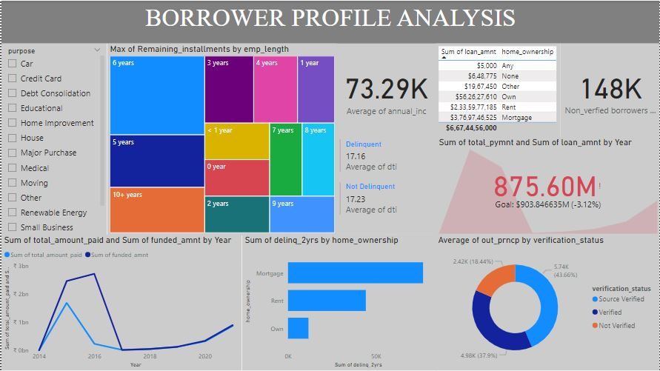

Here I gave the proper insights for borrower profile analysis .

Conclusion:

Through this I performed relationship between both dataset and then analysis the proper data visualizations for each question , which is given above. though this we can empower banking institutions with actionable insights to optimize loan lending strategies.